TASK 3: REBRAND A FAMOUS BRAND’S WEBSITE USING AI

Title : LIC Plans Rebrand – UI/UX Modernization

Name: Divya L

Internship Domain: Full stack web development

Internship at:[Future interns]

Date of Submission:[26-07-2025]

🔗 GitHub Repo link: https://github.com/Divyalogaraja/FUTURE_FS_03.git

**Objective:**  
To redesign the LIC website’s /plans page using modern frontend technologies and AI-powered design principles, focusing on clarity, responsiveness, and portfolio-grade presentation.

**Tech Stack:**

* Next.js (App Router)
* TypeScript
* Tailwind CSS
* Zustand (for state management)
* AI tools for branding and layout inspiration

**Key Goals:**

* Create reusable components for plan listings
* Implement responsive design with Tailwind
* Integrate icons and dynamic data
* Document the process for reproducibility

**Design Rationale & Branding**

**Design Inspiration:**  
Used AI tools (e.g., Uizard, Looka) to explore modern insurance branding. Focused on trust, clarity, and accessibility.

**Color Palette:**

* Primary: Deep Blue (#1E3A8A) – Trust & Stability
* Accent: Gold (#FBBF24) – Value & Prestige
* Background: Light Gray (#F3F4F6) – Clean & Neutral

**Typography:**

* Headings: Inter – Bold, modern
* Body: Roboto – Readable, professional

**Layout Choices:**

* Hero section with call-to-action
* Grid-based plan cards with icons
* Sticky navigation for easy access

**AI Contribution:**  
Generated layout mockups and branding suggestions to align with LIC’s legacy while modernizing the feel.

**Technical Implementation**

**Folder Structure:**

/app

/plans

.page.tsx

/components

. PlanCard.tsx

/data

.plans.ts

/public

/icons

**Key Components:**

* PlanCard.tsx: Reusable card with props for title, description, icon
* plans.ts: Dynamic data file for plan listings
* Responsive layout using Tailwind’s grid and flex utilities

**State Management:**

* Zustand used for cart simulation and plan selection (optional enhancement)

**Challenges Solved:**

* Windows vs Unix path issues
* Icon rendering and accessibility
* Dynamic routing and layout consistency

**Screenshots & Visuals**

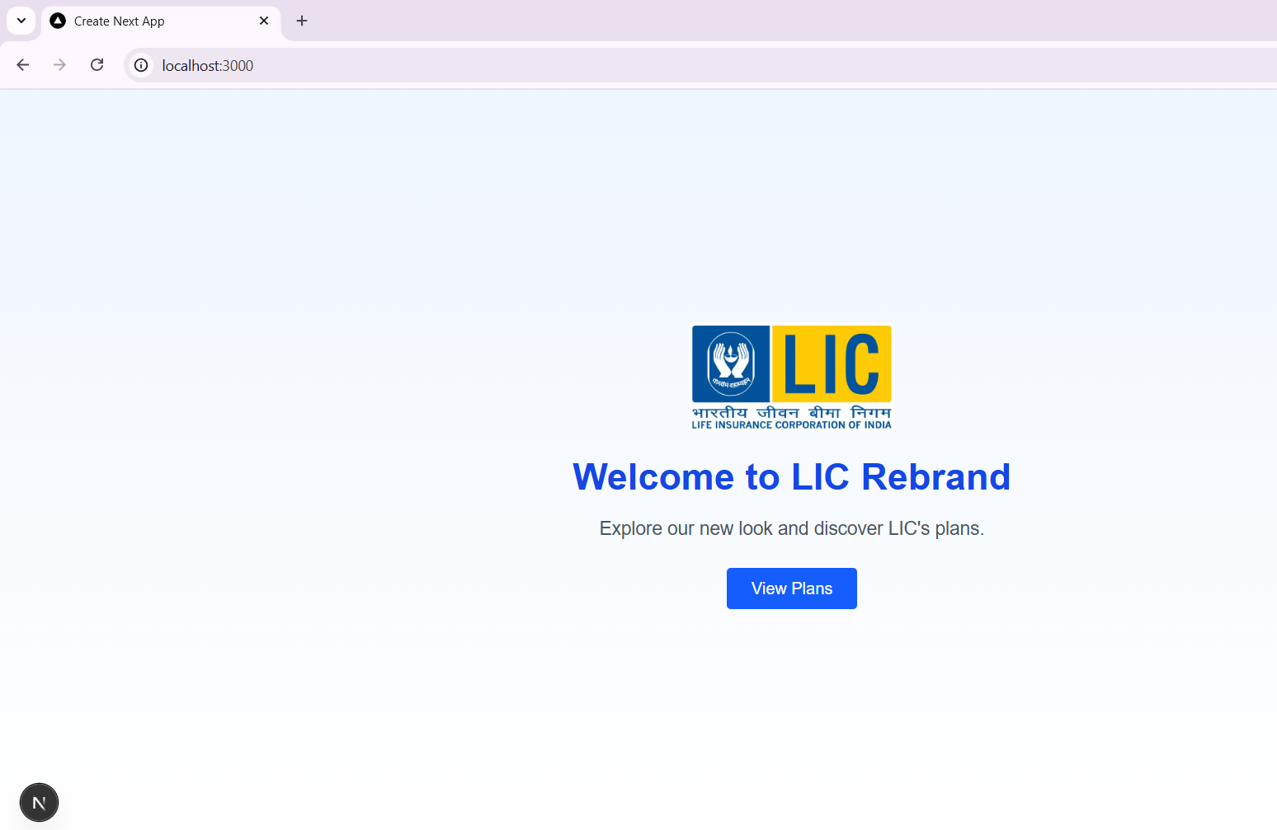

**LIC Rebrand – Hero Section with CTA**

A clean, responsive landing page introducing LIC’s modernized branding. Features a welcoming headline, brand logo, and a clear call-to-action button guiding users to explore available plans.

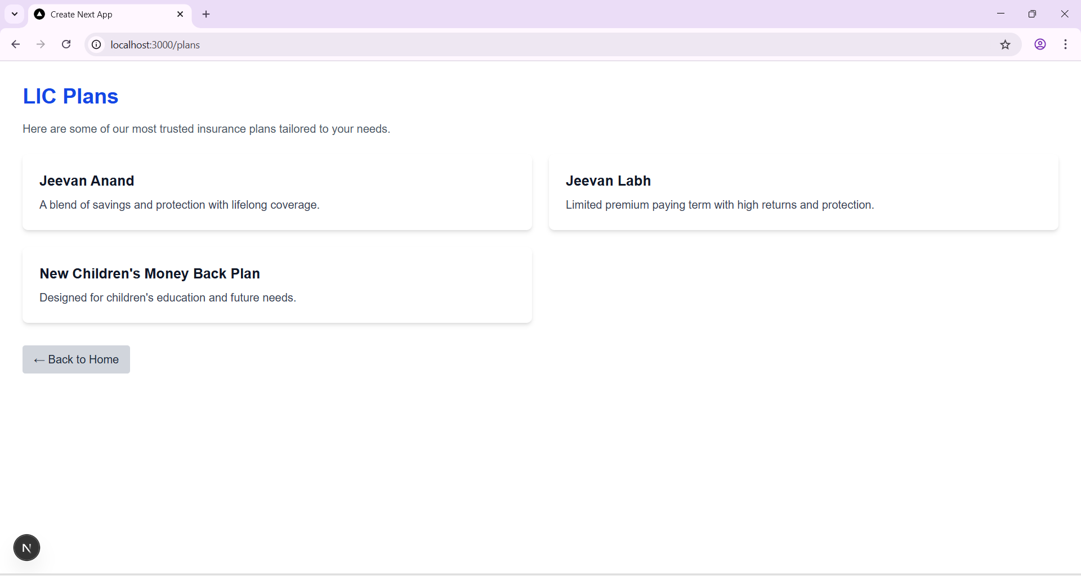

**LIC Plans Page – Responsive Grid with Plan Highlights**

Displays three key insurance offerings—Jeevan Anand, Jeevan Labh, and New Children’s Money Back Plan—in a clean, accessible layout. Each card includes a brief description, with a navigation button to return to the homepage.

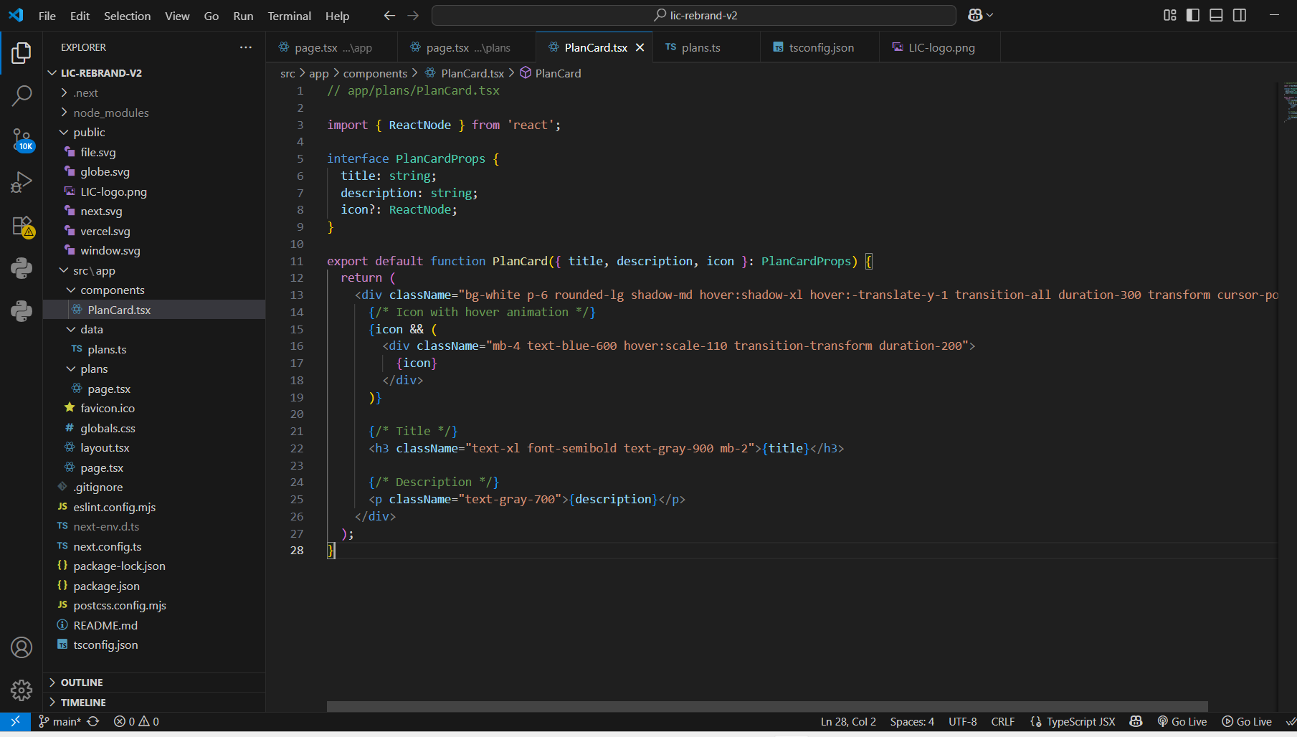

**PlanCard Component – Modular UI for LIC Plans**

A reusable React component built with TypeScript and Tailwind CSS, designed to display insurance plans with dynamic icons, titles, and descriptions. Includes hover animations and responsive styling for a polished user experience.

🟦  **Reflection & Next Steps**

**What I Learned:**

* Structuring reusable components for scalability
* Applying branding principles to real-world redesigns
* Documenting technical decisions for portfolio clarity

**Next Steps:**

* Expand to full LIC site redesign (homepage, contact, CMS integration)
* Add cart simulation and checkout flow using Zustand
* Deploy live demo and integrate into personal portfolio

**Final Note:**

This project reflects my commitment to clarity, reproducibility, and professional presentation. I welcome feedback and look forward to evolving this into a full case study.